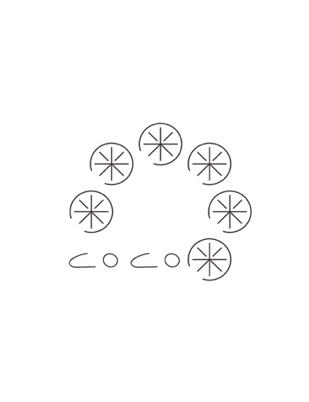xinke zhuang

CBN#1909 1946 CAMPUS DRIVE, HYDE PARK, NY 12538

TELEPHONE: +1(843)860-1814 EMAIL: xinke.zhuang@cia.culinary.edu

# REFERENCES

**Mr. Martin Matysik Assistant Professor**

*Culinary Arts - Specialization*

*The Culinary Institute of America Hyde Park, New York*

*Email:*[*martin.matysik@culinary.edu*](mailto:martin.matysik@culinary.edu)

*TEL: 845-905-4760*

Mr. Matysil is the assistant professor in the Culinary Institute of America, specialized in culinary arts; Mr. Matysik teaches me the culinary fundamentals during my first semester as an associate degree students in Culinary Arts. He would describe me as a coachable person and give commence on my professional performance.

**Miss Bingzi Du Co-Founder**

*MiaandCo.Co.Ltd Beijing, China*

*Email:*[*dubingzi@163.com*](mailto:dubingzi@163.com)

*TEL: +8618610150112*

Miss Du is the Co-founder of MiaandCo,Co.Ltd. we started our business in media industry since 2017. She would definitely describe me as innovative, well-organized personality with ambition and achievement.

**Mrs. Yuan Zhang Department Manager**

*Sunshine Asset Management Corp, Ltd Beijing, China*

*Email:*[*Zhangyuan-ghq@sinosig.com*](mailto:Zhangyuan-ghq@sinosig.com)

*TEL: +8613911179625*

Miss Zhang is the manager of Financial Management Department, as my group leader. She will describe me as analytical thinking person, with high standard ability on stress tolerance, also with willingness to lead and take charge.

**Miss Xuling (Leila) Sun Head of Business Development**

**t***héATRE (Beijing) food and beverage management Co., Ltd. Beijing, China*

*Email:*[*Leila@theatretea.com*](mailto:Leila@theatretea.com)

*TEL: +86 18710106055*

Miss Sun is the head of business development of théATRE (Beijing) food and beverage management Co., Ltd. We have good relationship in business cooperation, and she recommended me to be a part-time line-cook chef in théATRE (Beijing). She would mostly describe me as adaptable and cooperated to new projects.