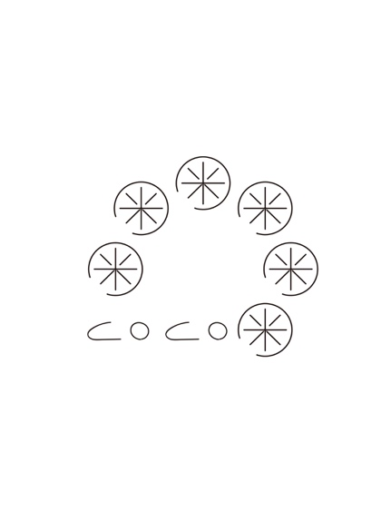xinke zhuang

**CBN#1909 1946 CAMPUS DRIVE, HYDE PARK, NY 12538**

**TELEPHONE: +1(843)860-1814 EMAIL:** xinke.zhuang@cia.culinary.edu

# OBJECTIVE

To obtain a Culinary Arts externship for 16 consecutive weeks between December 2019 and March 2020, to help me increase my abilities in food preparation, and expand my culinary knowledge.

# EDUCATION

**The Culinary Institute of America**  *Hyde Park, New York*

*(04.2019- present)*

* Candidate for Associate Occupational Studies, Culinary Arts
* Anticipated graduation date, April 2021;

**University of Reading, Henley Business School, ICMA**  *Reading, United Kingdom*

*(09.2012-07.2013)*

* Graduated with Master Degree in MSC International Securities, Investment and Banking with merit;

# EXPERIENCE

Sunshine Asset Management Corp Ltd/Sunshine Insurance Group *Beijing, China*

***Senior Manager (11.2014-03.2019)***

* In charge of investment portfolio margin management by calculating, monitoring and tracking, in both on-shore market and off-shore market;
* Responsible for daily trading support by trading status uploading, including bond market and stock market;
* In charge of daily trading settlement and clearing;
* Investment customer services supplement in the field of investment account management;
* Leadership in terms of new employee training.

# SPECIALIZED PERSONALITY

* Blogger (Food & Travel) from China since 2017;

Over 2-year experience on food and travel writing and video making;

Co-founder of star-up business in media industry in China.

* Global traveler: having been to more than 30 countries and areas.